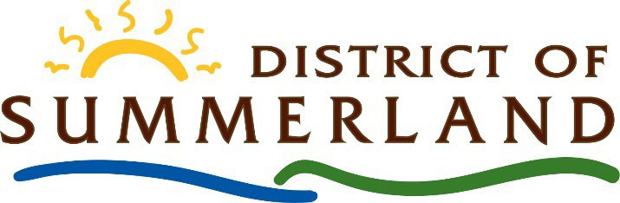

NOTICE OF COMMITTEE OF THE WHOLE COUNCIL MEETING

A Committee of the Whole Meeting of Municipal Council will be convened at the District of Summerland, 13211 Henry Avenue, Summerland, BC, on

July 2, 2024 at 10:00 A.M.

The purpose of the Committee of the Whole meeting is to receive information on the distributed generation program.

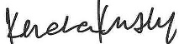

Kendra Kinsley, Corporate Officer

Posted: June 13, 2024

